CS 385, Homework 4: Decrease/Divide and Conquer

Name: Jessica Noel Date: 10/29/2020

Point values are assigned for each question. Points earned: ____ / 100

1. Consider the algorithm on page 148 in the textbook for binary reflected Gray codes. What change(s) would you make so that it generates the binary numbers **in order** for a given length n? Your algorithm must be recursive and keep the same structure as the one in the textbook. Describe only the change(s). (10 points)

When you copy L1 to L2, append L1 in regular order.

1. Show the steps to multiply 72 x 93 with Russian peasant multiplication, as seen in Figure 4.11b on page 154 in the textbook. (10 points)

n m

72 93

36 186

18 372

9 744 744 744 + 5952 = 6696

4 1488

2 2976

1 5952 5952

1. Suppose you use the LomutoPartition() function on page 159 in the textbook in your implementation of quicksort. (10 points, 5 points each)
   1. Describe the types of input that cause quicksort to perform its worst-case running time. b. What is that running time?

a. An example of a worst-case running time for quicksort would be an array that is presented in greatest to least order (reversed order sorted array).

b. The runtime for this would be Θ(n2)

1. Compute 2205 x 1132 by applying the divide-and-conquer algorithm outlined in the text. Repeat the process until the numbers being multiplied are each 1 digit. For each multiplication, show the values of c2, c1, and c0. Do not skip steps. (10 points)

C0 = 05 * 32 = 160

C1 = (22 + 05) * (11 + 32) – (2 + 0)

= 27 * 43 – (242 + 160)

= 1161 – 402 = 759

C2 = 22 * 11 = 242

C = (242 * 104) + (759 * 102) + (160) = 2496060

05 * 32 = 160 22 * 11 = 242 27 * 43 = 1161

C0 = 5 * 2 = 10 C0 = 2 * 1 = 2 C0 = 7 * 3 = 21

C1 = (5) * (5) – (10) = 15 C1 = (4) * (2) – (4) = 4 C1 = (2+7) * (4+3) – (8+21) = 34

C2 = 0 * 3 = 0 C2 = 2 * 1 = 2 C2 = 2 * 4 = 8

C = (0 * 102) + (15 * 10) + 10 C = (2 * 102) + (4 * 10) + 2 C = (8 * 102) + (34 * 10) + 21

1. Draw the binary search tree after inserting the following keys: 24 18 67 68 69 25 19 20 11 93 (10 points)

24

/ \

18 67

/ \ / \

11 19 25 68

\ \

20 69

\

93

1. Consider the following binary tree. (16 points, 2 points each)

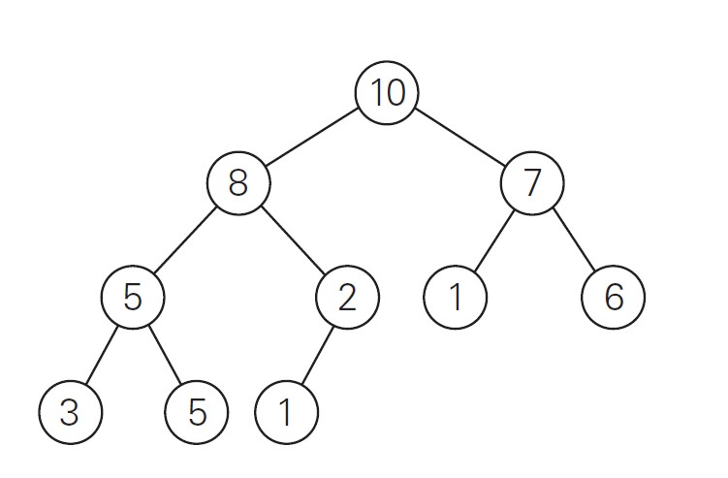

* 1. Traverse the tree preorder.

10, 8, 5, 3, 5, 2, 1, 7, 1, 6

* 1. Traverse the tree inorder.

3, 5, 5, 8, 1, 2, 10, 1, 7, 6

* 1. Traverse the tree postorder.

3, 5, 5, 1, 2, 8, 1, 6, 7, 10

* 1. How many internal nodes are there?

5

* 1. How many leaves are there?

5

* 1. What is the maximum width of the tree?

4

* 1. What is the height of the tree?

3

* 1. What is the diameter of the tree?

6

1. Use the Master Theorem to give tight asymptotic bounds for the following recurrences. (25 points, 5 points each)

CS 385, Homework 4: Decrease/Divide and Conquer

* 1. 𝑇(𝑛) = 2𝑇(𝑛/4) + 1

Θ ( )

* 1. 𝑇(𝑛) = 2𝑇(𝑛/4) +

Θ ( log4n)

* 1. 𝑇(𝑛) = 2𝑇(𝑛/4) + 𝑛

Θ (n)

* 1. 𝑇(𝑛) = 2𝑇(𝑛/4) + 𝑛2

Θ (n2)

* 1. 𝑇(𝑛) = 2𝑇(𝑛/4) + 𝑛3

Θ (n3)

1. Consider the following function. (9 points)

int function(int n) { if (n <= 1) { return 0;

} int temp = 0; for (int i = 1; i <= 6; ++i) { temp += function(n / 3);

} for (int i = 1; i <= n; ++i) { for (int j = 1; j * j <= n; ++j) {

++temp;

}

}

return temp;

}

1. Write an expression for the runtime 𝑇(𝑛) for the function. (4 points)

T(n) = 6T ($\frac{n}{3}$) + Θ (n (3/2))

1. Use the Master Theorem to give a tight asymptotic bound. Simplify your answer as much as possible. (5 points)

Θ(nlog36)